

**WEEK - 6**

**Computer Networks**

**M. Sumanth Reddy**

**1. Implement Client and Server communication with socket using TCP protocol.**

Socket programming is a way of connecting two nodes on a network to communicate with each other. One socket(node) listens on a particular port at an IP, while the other socket reaches out to the other to form a connection. The server forms the listener socket while the client reaches out to the server.

They are the real backbones behind web browsing. In simpler terms, there is a server and a client.   
Socket programming is started by importing the socket library and making a simple socket.

**Import socket**

**Server:**

A server has a bind() method which binds it to a specific IP and port so that it can listen to incoming requests on that IP and port. A server has a listen() method which puts the server into listening mode. This allows the server to listen to incoming connections. And last a server has an accept() and close() method. The accept method initiates a connection with the client and the close method closes the connection with the client.

**CODE:**

import socket  
*# creating a socket*  
*# s - server socket*  
*# socket contains two arguments, by default - type of address (IPV4, IPV6), type of protocol(TCP/UDP)*  
s = socket.socket()  
print('Socket is created')  
*# port number range 0 to 65535*  
s.bind(('localhost',123))  
*# decide at one point, how many clients you want to connect*  
s.listen(2) *# maintain buffer for 3 connections*  
print('Waiting for connections')  
*# to process multiple requests from client continuously*  
while True:  
 *# i want to accept a connection from the client*  
c, addr = s.accept() *# it returns client socket and address*  
name = c.recv(1024).decode()  
 print('Connected with', addr, name)  
 c.send(bytes('Welcome to socket connection','utf-8'))  
 *#c.send('Welcome to socket connection')*  
c.close()

**Client:**

We will save python socket client program as Client.py. This program is like the server program, except binding. The main difference between server and client program is, in server program, it needs to bind host address and port address together. See the below python socket client example code, the comment will help you to understand the code.

**CODE:**

import socket  
c = socket.socket() *# you can mention the two arguments, if u want to change the default arguments*  
*# connecting to the server*  
*# Pass two pararmeters - IP address of the server and port no. which u want to connect with*  
c.connect(('localhost',123)) *# ip address of the server*  
*# asking the user to send the nameR*  
name = input('Enter your name:')  
c.send(bytes(name,'utf-8'))  
print(c.recv(1024).decode()) *# set buffer size*

**OUTPUT:**

To get the output we should run the firstly **Server.py** and after Client.py then

Running **Server.py**

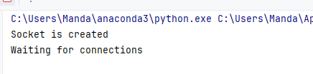

After running **Server.py** then run **Client.py**

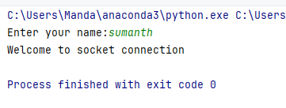

Then after typing the name sumanth come back to **Server.py** output:

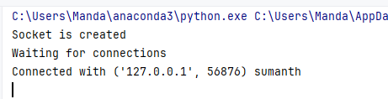

Socket server is running on port 5000 but client also requires a socket port to connect to the server. This port **56876** is assigned randomly by client connect call. Th